Profile of the

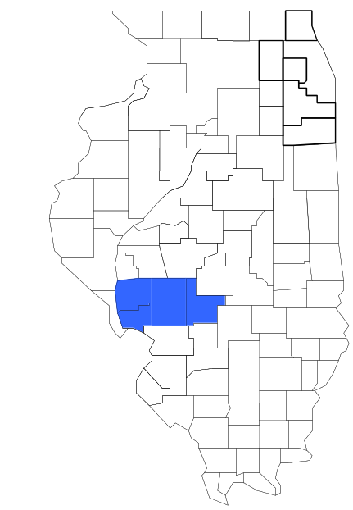South Central Illinois

Drug Task Force

Prepared by

The Research and Analysis Unit of the
Illinois Criminal Justice Information Authority

George H. Ryan, Governor
Peter B. Bensinger, Chairman
Candice M. Kane, Executive Director

March 2001



ILLINOIS
CRIMINAL JUSTICE
INFORMATION AUTHORITY

This project was supported by Grant # 99-DB-BX-0017, awarded to the Illinois Criminal Justice Information Authority by the Bureau of Justice Assistance, Office of Justice Programs, U.S. Department of Justice. The Assistant Attorney General, Office of Justice Programs, coordinates the activities of the following programs, offices and bureaus: Bureau of Justice Assistance, Bureau of Justice Statistics, National Institute of Justice, Office of Juvenile Justice and Delinquency Prevention, and the Office for Victims of Crime. Points of view or opinions contained within this document are those of the authors and do not necessarily represent the official position or policies of the U.S. Department of Justice.

Illinois Criminal Justice Information Authority
120 S. Riverside Plaza, Suite 1016
Chicago, Illinois 60606-3997
Telephone (312) 793-8550
Telefax (312) 793-8422
TDD: (312) 793-4170
World Wide Website http://www.icjia.state.il.us
ACKNOWLEDGMENTS

A number of organizations and individuals put a great deal of effort into the development of this document. The Authority’s Research and Analysis Unit is very grateful for the assistance provided by the following organizations:

Administrative Office of the Illinois Courts
Illinois Department of Human Services’ Office of Alcoholism and Substance Abuse
Illinois Department of Children and Family Services
Illinois Department of Corrections
Illinois State Police
South Central Illinois Drug Task Force
U.S. Bureau of the Census

In addition, the following individuals were instrumental in gathering, interpreting and presenting these data:

Sharyn Adams

Megan Alderden

Robert Bauer

Alissa Clark

John Condne

Karen Griffiths

Tracy Hahn

Jennifer Hiselman

David Katz

Joseph Kozenczak

Gary Kupsak

Erica Morrow

David Olson

Adrianna Perez

Gerard Ramker

Robert Taylor

CONTENTS

Section Page Number

EXECUTIVE SUMMARY

I. Introduction 1
II. Trends in Violent Index Offenses and Arrests 3
III. Trends in Drug Arrests 6
IV. Trends in Drug Seizures 14
V. Trends in Prosecutions for Drug Offenses 16
VI. Trends in Percent of Convicted Drug Offenders Sentenced to Prison 18
VII. Trends in Drug Treatment Admissions in SCIDTF Region by Drug Type 23
VIII. Trends in Drug Exposed Births 26
IX. Summary of Drug Situation 27
X. Appendices 30
Map 1 1999 Percent of Illinois' County-level Population Covered by an
Authority-funded Multi-jurisdictional Enforcement Group or Task Force 31
Map 2 1999 Illinois Cannabis Seizure Rates, by County 32
Map 3 1999 Illinois Controlled Substances Seizure Rates, by County 33
Map 4 1999 Illinois Methamphetamine Seizure Rates, by County 34
XI. Bibliography 35

LIST OF FIGURES

Figure Page Number

Figure 1. Violent Index Offense Rates for Participating and Non-participating Agencies in Region Covered by SCIDTF 3
Figure 2. 1999 Violent Index Offenses* Reported by Participating and Non-participating Agencies in Region Covered by SCIDTF 4
Figure 3. Violent Index Arrest Rates for Participating and Non-participating Agencies in Region Covered by SCIDTF 5
Figure 4. 1999 Violent Index Arrests* Reported by Participating and Non-participating Agencies in Region Covered by SCIDTF 5
Figure 5. Total Drug Arrest Rates for SCIDTF and Participating and Non-participating Agencies in Region Covered by SCIDTF 7
Figure 6. 1999 Drug Arrests* Reported by Participating and Non-participating Agencies in Region Covered by SCIDTF 7
Figure 7. Total 1999 Drug Arrests* Reported by Participating and Non-participating Agencies in Region Covered by SCIDTF, by Drug Type 8
Figure 8. Drug Arrests by SCIDTF 9
Figure 9. Percent of Total Drug Arrests Accounted for by SCIDTF 9
Figure 10. Cannabis Arrests Rates in the Region Covered by SCIDTF as Reported by Participating Agencies, Non-participating Agencies and SCIDTF 10
Figure 11. Percent of Cannabis Arrests Accounted for by SCIDTF
11
Figure 12. Controlled Substances Arrest Rates in the Region Covered by SCIDTF as Reported by Participating Agencies, Non-participating Agencies and SCIDTF 12
Figure 13. Percent of Controlled Substances Arrests Accounted for by SCIDTF 12
Figure 14. SCIDTF Drug Arrests for Possession versus Delivery, by Drug Type 13
Figure 15. Cannabis Seized and Submitted to ISP by Jersey, Macoupin, Montgomery and Greene Counties and Seized by SCIDTF 14
Figure 16. Powder and Crack Cocaine Seized and Submitted to ISP by Jersey, Macoupin, Montgomery and Greene Counties and Seized by SCIDTF 15
Figure 17. Number of Felony Filings in Jersey, Macoupin, Montgomery and Greene Counties 16
Figure 18. Total SCIDTF Drug Arrests and Percentage of Arrests Resulting in Felony Prosecution 17
Figure 19. Sentences Imposed on Felons Convicted in Jersey, Macoupin, Montgomery and Greene Counties
18
Figure 20. Sentences Imposed on Convicted SCIDTF Drug Offenders 19
Figure 21. Number of Drug Offenders Committed to IDOC by SCIDTF and Region Covered by SCIDTF 20
Figure 22. Drug Offenders as a Percent of Total IDOC Commitments from Jersey, Macoupin, Montgomery and Greene Counties 21
Figure 23. Drug Offenders Committed to IDOC from Jersey, Macoupin, Montgomery and Greene Counties, by Offense Class 22
Figure 24. Substance Abuse Treatment Admissions from Jersey, Macoupin, Montgomery, and Greene Counties 23
Figure 25. Comparison of Drug Arrests by SCIDTF and Participating and Non-participating Agencies vs. Drug Abuse Treatment Admissions in Jersey, Macoupin, Montgomery and Greene Counties, SFY 99 25
Figure 26. Cases of Drug-Exposed Infants in Jersey, Macoupin, Montgomery and Greene Counties 26
Figure 27. Availability of Drugs in Illinois, 1998 27
Figure 28. Price Per Gram in Illinois, 1998 28

EXECUTIVE SUMMARY

Since 1989, the Authority’s Research and Analysis Unit has received funds under the federal Anti-Drug Abuse Act of 1988 to document the extent and nature of drug and violent crime in Illinois and the criminal justice system’s response to these offenses. As a result of these efforts, the Authority has amassed a large amount of data measuring the extent and nature of drug and violent crime in Illinois and the impact these crimes have had on the criminal justice system. In addition, as part of its monitoring and evaluation efforts, the Authority also requires funded programs to submit monthly data reports describing their activities and accomplishments. This profile is intended to provide a general overview of the drug and violent crime problem in the jurisdictions covered by Illinois’ MEGs and task forces, and the response to these problems by the units.

Although the data presented in this report are by no means inclusive of all indicators, they do provide a general overview of drug and violent crime and the response and impact of the criminal justice system. The following represent general conclusions that can be made based on the data analyzed for this report.

- In 1999, five local Illinois police agencies participated in SCIDTF (a participating agency is defined as one that contributes either personnel or financial resources to SCIDTF). Officers assigned to SCIDTF (totaling six in 1999, five from participating agencies) accounted for more than seven percent of the total number of sworn police officers working for agencies participating in SCIDTF.

- The violent Index offense rate was collectively higher across jurisdictions that did not participate in SCIDTF than among the combined jurisdictions that did participate in SCIDTF (page 3).

- The drug arrest rate was collectively higher in those jurisdictions that did not participate in SCIDTF than in those jurisdictions that did participating in SCIDTF. Also, the drug arrest rate achieved by SCIDTF was relatively close to that experienced by the participating agencies, meaning that the unit mad almost as many arrests for violations of the Cannabis Control and Controlled Substances Act, with six officers, as did all of the participating agencies combined (page 6).

- When comparing the types of drug offenders arrested by those agencies participating in SCIDTF, those agencies not participating and SCIDTF, it was found that in three out of the four last years SCIDTF tended to target and arrest more serious drug law violators, specifically violators of the Controlled Substances Act, which tend to be felony-level offenses. However, it should be noted that arrests for violations of the Cannabis Control Act accounted for the majority of arrests for participating and non-participating agencies, as well as for SCIDTF (page 9).

- The majority of all drug arrests reported by SCIDTF, for either violations of the Cannabis Control Act or the Controlled Substances Act, involve drug sale or delivery (page 14).

- Between 1993 and 1999, the amount of cannabis seized by SCIDTF decreased dramatically, while the amount of cocaine seized by SCIDTF decreased slightly (pages 15 and 16).

- Between 1990 and 1999, the majority of all drug arrests by SCIDTF resulted in prosecution. Of those offenders prosecuted, 39 percent were prosecuted for violation of the Controlled Substances Act. In addition, between 1990 and 1999, 93 percent of all drug offenders who were prosecuted as a result of SCIDTF activity were convicted (page 18).

- In 1999, among those SCIDTF drug offenders convicted and sentenced, probation sentences accounted for the largest proportion (37 percent), followed by jail sentences (33 percent) and prison sentences (30 percent) (page 20).

- Between 1989 and 1999, prison sentences resulting from SCIDTF cases accounted for only eight percent of all drug-law violators sent to prison from the region where SCIDTF operates (page 21).

- Unlike the arrests made by the participating and non-participating agencies, the arrests made by SCIDTF tended to involve substances considered to be the most serious (i.e., felony versus misdemeanor) and the substances for which a large proportion of community residents were seeking and receiving substance abuse treatment in 1999 (page 25).

I. Introduction

The South Central Illinois Drug Task Force (SCIDTF) covers the Illinois counties of Jersey, Macoupin, Montgomery and Greene. Combined, these counties had a 1999 total population of 770,876 – 3 percent more than in 1990. In 1999, five local Illinois police agencies participated in SCIDTF. These include the Jersey County Sheriff’s Office, Macoupin County Sheriff’s Office, Montgomery County Sheriff’s Office, and the following municipal police departments: Carlinville and Carrollton. These agencies served 45 percent of the population in the four-county region covered by SCIDTF in 1999 (see Map 1 on page 31). A participating agency is defined as one that contributes either personnel or financial resources to SCIDTF.

In addition to agencies that participate in SCIDTF, these Illinois counties are served by 33 additional police departments that do not participate in SCIDTF. According to the Illinois State Police, county sheriffs and local police departments, in the four-county region covered by SCIDTF, combined, employed 147 full-time police officers as of Oct. 31, 1999. In comparison, there were a total of six officers assigned to SCIDTF of which five were assigned by participating agencies and one from the Illinois State Police (ISP) in 1999. Thus, the officers assigned to the SCIDTF during 1999 accounted for a relatively small proportion - 7 percent - of the total number of sworn police officers working in the participating police departments, and the region as a whole.

Since 1989, the Authority’s Research and Analysis Unit has received funds under the federal Anti-Drug Abuse Act of 1988 to document the extent and nature of drug and violent crime in Illinois and the criminal justice system’s response to these offenses. As a result of these efforts, the Authority has amassed a large amount of data measuring the extent and nature of drug and violent crime in Illinois and the impact these crimes have had on the criminal justice system. In addition, as part of its monitoring and evaluation efforts, the Authority also requires funded programs to submit monthly data reports describing their activities and accomplishments. To put this information into the hands of Metropolitan Enforcement Group (MEG) and drug task force directors and policy board members, the Authority’s Research and Analysis Unit has developed profiles – of which this is one – for each MEG and task force. The profile is intended to provide a general overview of the drug and violent crime problem in the jurisdictions covered by Illinois’ MEGs and task forces, and the response to these problems by the units.

In addition to administering federal block-grant funds that come to Illinois for crime control initiatives, the Illinois Criminal Justice Information Authority is also responsible for providing policymakers, criminal justice professionals and others with information, tools and technology needed to make effective decisions that improve the quality of criminal justice in Illinois. The Authority provides an objective system-wide forum for identifying critical problems in criminal justice, developing coordinated and cost-effective strategies, and implementing and evaluating solutions to those problems. The specific powers and duties of the Authority are delineated in the Illinois Criminal Justice Information Act (Illinois Compiled Statutes, Ch. 20, Sec. 3930). Two of the Authority’s many responsibilities are serving as a clearinghouse of information and research on criminal justice and undertaking research studies to improve the administration of criminal justice.

While the data presented in this report are by no means inclusive of all indicators, they do provide a general overview of drug and violent crime and the response and impact of the criminal justice system. In addition, these data are readily available and consistently defined through existing statewide data collection mechanisms. Some data presented in this profile have been analyzed differently than in previous years; therefore, caution must be taken when comparing numbers presented with previous profiles.
While a considerable amount of the information presented in this profile has been provided to the Authority by SCIDTF, a number of state agencies have also provided data to the Authority that are included in this report. Specifically, the Illinois State Police, the Administrative Office of the Illinois Courts, the Illinois Department of Human Services’ Office of Alcoholism and Substance Abuse, the Illinois Department of Corrections and the Illinois Department of Children and Family Services all provided data used to develop this profile. The support and cooperation of these agencies and their staffs have helped make this report an informative and timely source of information on the activities of the criminal justice system in Illinois.

- Trends in Violent Index Offenses and Arrests

While most of Illinois’ Metropolitan Enforcement Groups and drug task forces are primarily involved in drug enforcement activities, it is clear that the relationship between drugs and violence is particularly evident in a number of Illinois communities. In addition, a number of MEGs and task forces have increased their involvement in the investigation of violent crime, particularly that associated with gang activity and violence related to drug distribution, sale and turf battles. One of the most commonly used indicators of the level of crime in a particular jurisdiction is the number of Index offenses reported to the police. In Illinois, as part of the Illinois Uniform Crime Reporting (I-UCR) program, every law enforcement agency in the state is required to report crime data monthly to the Illinois State Police (ISP). There are eight separate offenses that constitute the Crime Index, including murder, criminal sexual assault, robbery, aggravated assault (violent Index offenses), burglary, theft, motor vehicle theft and arson (property Index offenses). Although these eight offenses do not account for all crimes reported to the police, they are considered to be the most serious, frequent, pervasive and consistently defined by different law enforcement agencies.

In 1999, the total number of violent Index offenses reported to the police in the four-county region where SCIDTF operates totaled 308, a 16 percent increase from the 266 offenses reported in 1993. The majority (88 percent) of violent Index offenses reported to the police between 1993 and 1999 were aggravated assaults, while 10 percent were criminal sexual assaults.

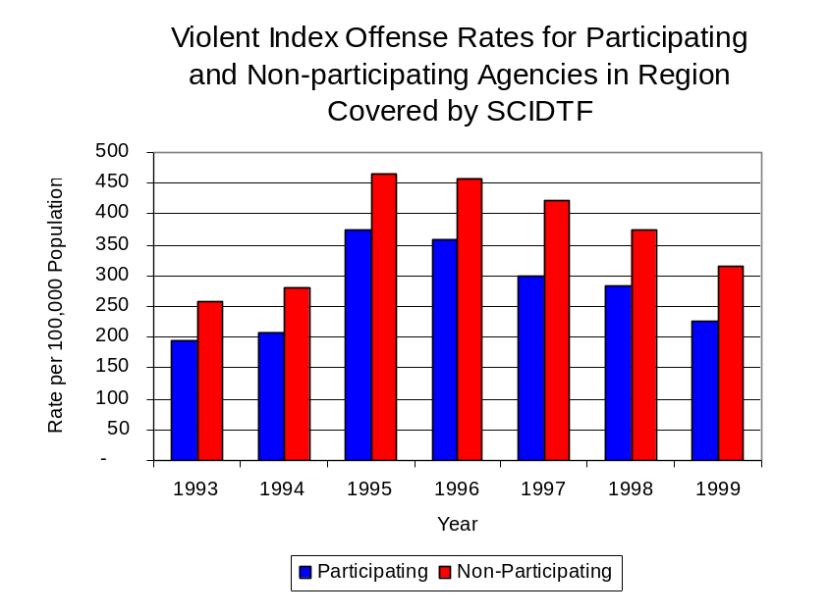
During the period analyzed, the violent Index offense rate for the region covered by SCIDTF increased 16 percent, from 410 offenses per 100,000 population in 1993 to 475 offenses per 100,000 population in 1999. Similarly, the violent Index offense rate in the participating agencies increased 17 percent, from 195 to 227 offenses per 100,000 population, while the rate in the non-participating agencies increased 7 percent, from 334 to 356 offenses per 100,000 population (Figure 1). Thus, the violent Index offense rate was collectively higher across the jurisdictions that did not participate in SCIDTF than it was among the combined jurisdictions that did participate in SCIDTF, and the difference has become even more dramatic over the past eight years.
Source: ICJIA calculations using Illinois State Police and U.S. Census Bureau data
Figure 1
Across the 40 individual local law enforcement agencies covered by SCIDTF’s jurisdiction, six agencies, the Carlinville Police Department, the Hillsboro Police Department, the Montgomery County Sheriff’s Office, the Litchfield Police Department, the Jersey County Sheriff’s Office and the Jerseyville Police Department, accounted for 61 percent of all violent offenses reported to the police (Figure 2). Twenty-three agencies had fewer than ten violent offenses reported in 1999 and are excluded from Figure 2. When controlling for differences in the populations served by these law enforcement agencies, the violent Index offense rate ranged from six violent Index offenses per 100,000 population in Carlinville to one offense per 100,000 population in Greene County.
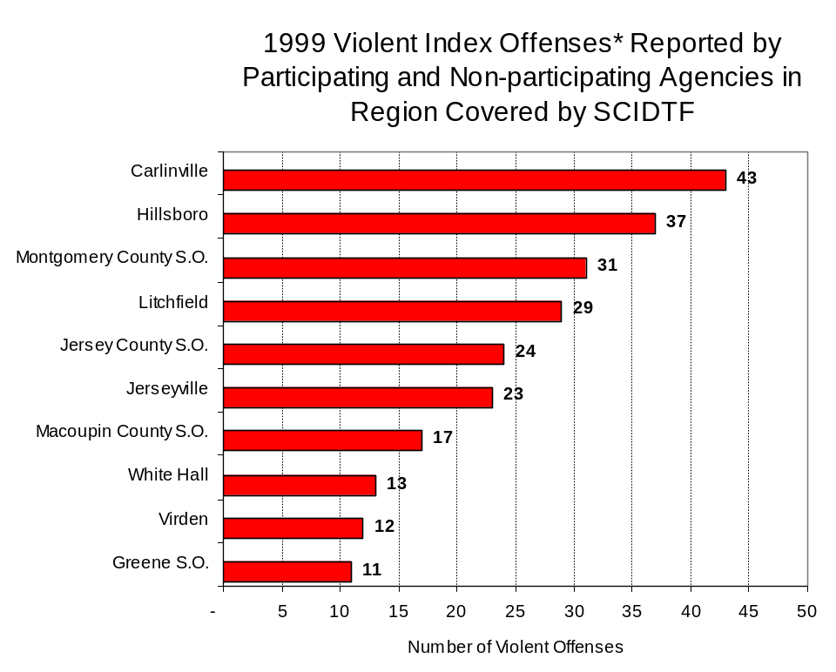
Source: Illinois State Police *Agencies reporting ten or more violent offenses
Figure 2

An indicator of the workload that law enforcement agencies place on other components of the justice system is the number of arrests made by police, including those for violent and property Index offenses and drug offenses. Unlike offenses, which are what police must respond to, arrests represent those offenders who may eventually be processed through other components of the justice system, including the courts, county jails, and state and local correctional programs.

Between 1993 and 1999, the number of arrests for violent Index offenses made by law enforcement agencies in the region covered by SCIDTF increased 30 percent, from 152 to 198. As with reported violent Index offenses, the majority (91 percent) of violent Index arrests were for aggravated assaults, followed by criminal sexual assault (8 percent).

During the period analyzed, the violent Index arrest rate for the region covered by SCIDTF increased 28 percent, from 234 offenses per 100,000 population in 1993 to 342 arrests per 100,000 population in 1999. Similarly, the violent Index arrest rate in the participating agencies increased 68 percent, from 107 to 157 offenses per 100,000 population and the rate in the non-participating agencies increased 5 percent, from 209 to 263 offenses per 100,000 population (Figure 3).
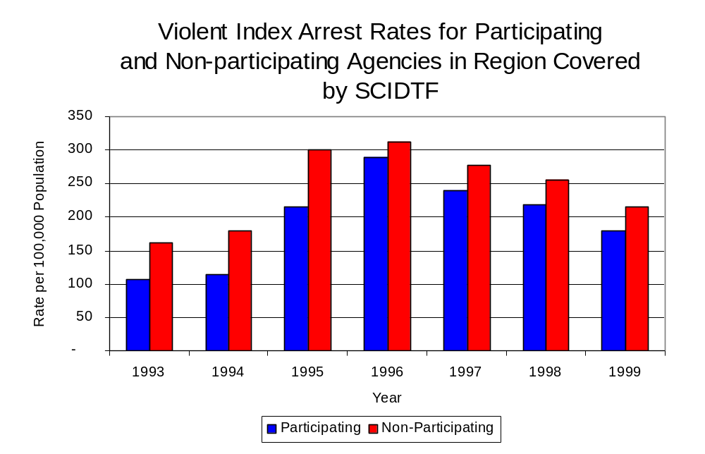
Source: ICJIA calculations using Illinois State Police and U.S. Census Bureau data
Figure 3

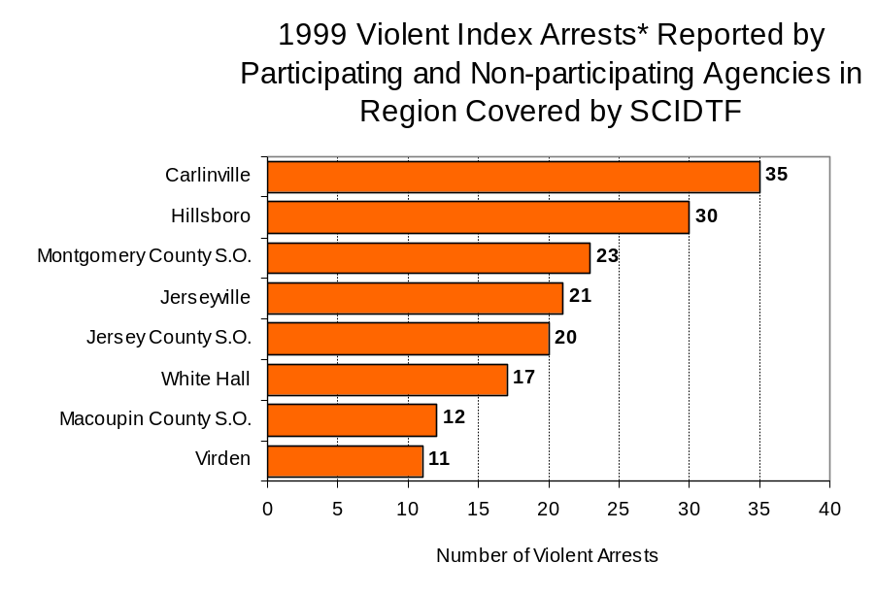
Nearly half (48 percent) of arrests for violent Index offenses occurring in the four-county region covered by SCIDTF were made by four agencies. Twenty-six agencies had fewer than ten arrests for violent Index offenses reported in 1999 and are excluded from Figure 4. Of the 222 violent Index arrests made in 1999, the Carlinville Police Department accounted for the majority (16 percent), followed by the Hillsboro Police Department (14 percent), the Jerseyville Police Department (9 percent) and the Jersey County Sheriff’s Office (9 percent) (Figure 4).
Source: Illinois State Police
Figure 4

III. Trends in Drug Arrests

There are two sources of drug arrest data presented in this section. One source is the Illinois Uniform Crime Reporting (I-UCR) program that includes information submitted by local law enforcement agencies on the number of persons arrested for violations of Illinois’ Cannabis Control Act, Controlled Substances Act, Hypodermic Syringes and Needles Act, and Drug Paraphernalia Control Act. In addition, data on drug arrests made by Illinois’ MEGs and task forces are reported to the Illinois Criminal Justice Information Authority. In some jurisdictions, arrests made by the MEG or task force may be reported by both local law enforcement agencies through the I-UCR and to the Authority by the unit. In other jurisdictions, arrests made by the MEG or task force are only reported to the Authority by the unit. Therefore, in some instances drug arrests may be double counted – included in both local agency statistics reported to I-UCR and those of the MEG or task force. Currently there is no mechanism in place to ensure that drug arrest statistics are not being duplicated at both the local agency and MEG/task force level. This should be kept in mind when interpreting the information presented in the following section.

The majority of drug offenses in Illinois are violations of either the Cannabis Control Act – which prohibits the possession, sale and cultivation of marijuana – or the Controlled Substances Act – which prohibits the possession, sale, distribution or manufacture of all other illegal drugs, such as cocaine and opiates. Illinois also has various other laws prohibiting other drug-related activity. These include the Hypodermic Syringes and Needles Act – which prohibits the possession or sale of hypodermic instruments – and the Drug Paraphernalia Control Act – which prohibits the possession, sale or delivery of drug paraphernalia. In general, violations of Illinois Controlled Substances Act are considered to be more serious, since they primarily involve cocaine, heroin, methamphetamine, and hallucinogens, and are almost all classified under Illinois law as felonies. The majority of cannabis and drug paraphernalia offenses encountered by police, on the other hand, tend to be misdemeanor-level offenses.

In 1999, local law enforcement agencies in the counties covered by SCIDTF reported 209 arrests for drug law violations, 12 percent more than the 187 arrests in 1993. Between 1993 and 1999, arrests for violations of Illinois’ Cannabis Control Act out-numbered arrests for violations of the Controlled Substances Act every year analyzed in Jersey, Macoupin, Montgomery and Greene counties combined. During the same period, the number of arrests for violations of the Cannabis Control Act in these four counties combined increased 16 percent, from 151 to 175. Arrests for violations of the Controlled Substances Act in the four counties combined decreased 6 percent, from 36 to 34. In addition, arrests for violations of the Drug Paraphernalia Control Act, enacted in 1993, increased more than 6 times, from 35 in 1993 to 236 in 1999. Much of this increase can be attributed to a 1994 addition to the Drug Paraphernalia Control Act, which included the possession of drug paraphernalia as a violation.

Because arrests for violations of the Drug Paraphernalia Control Act are frequently made in conjunction with other drug offense arrests, these arrests may be double-counted, thus skewing the actual number of drug arrests. Therefore, only arrests for violations of the Cannabis Control Act and Controlled Substances Act will be used for drug arrest comparisons between SCIDTF and the participating and non-participating agencies.

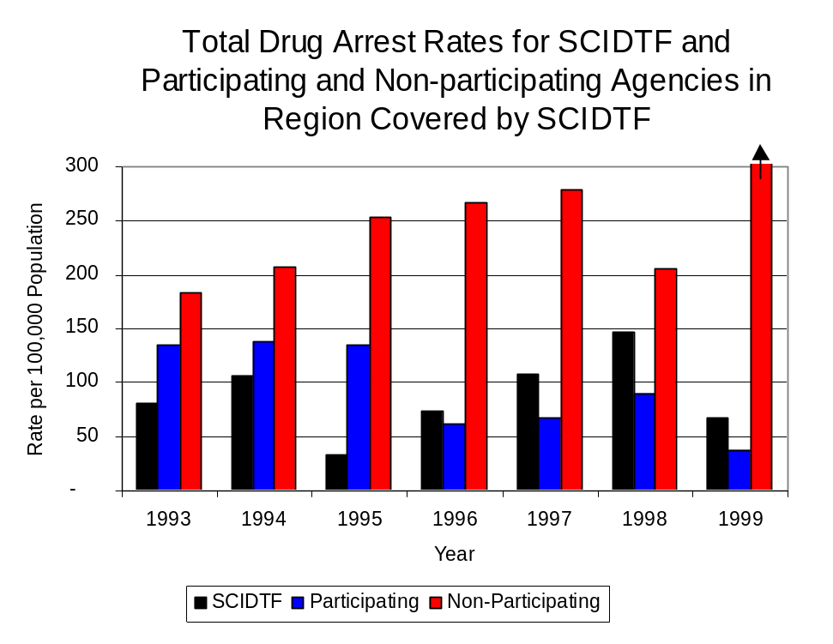
During the period analyzed, the drug arrest rate in the region covered by SCIDTF for the Cannabis Control and Controlled Substances Acts, combined, more than doubled, from 81 arrests per 100,000 population in 1993 to 147 arrests per 100,000 population in 1998. However, between 1998 and 1999 the arrest rate decreased 54 percent from 147 to 68 per 100,000 population. The drug arrest rate in the participating agencies decreased 72 percent, from 135 to 38, while the drug arrest rate for non-participating agencies greatly increased from 183 to 645 arrests per 100,000 population. The arrest rate for SCIDTF decreased 17 percent, from 81 to 68 arrests per 100,000 population (Figure 5). Thus, the drug arrest rate tended to be higher collectively in the jurisdictions that did not participate in SCIDTF than in those jurisdictions that did participate in SCIDTF. Also, the drug arrest rate achieved by SCIDTF was relatively close to that experienced by the participating agencies, meaning that the unit mad almost as many arrests for violations of the Cannabis and Controlled Substances Act, with six officers, as did all of the participating agencies combined.
Source: ICJIA calculations using Illinois State Police, SCIDTF and U.S. Census Bureau data
Figure 5

Across the individual local law enforcement agencies in the region covered by SCIDTF, the total number drug arrests, including those made from the Cannabis Control Act, the Controlled Substance Act, the Hypodermic Syringes and Needles Act and the Drug Paraphernalia Control Act, ranged from zero to 79. Of the 450 drug arrests made during 1999 in the four-county region, five agencies accounted for 53 percent of these drug arrests. Twenty-five agencies had fewer than 20 drug arrests reported in 1999 and are excluded from Figure 6. The Jerseyville Police Department accounted for 18 percent, while the Litchfield Police Department accounted for 12 percent, the Hillsboro Police Department accounted for 10 percent, the Palmyra Police Department and the Macoupin County Sheriff’s Office accounted for 7 percent each of the total drug arrests in Jersey, Macoupin, Montgomery and Greene counties (Figure 6). Among the five agencies with the highest number of drug arrests during 1999, one participated in SCIDTF.

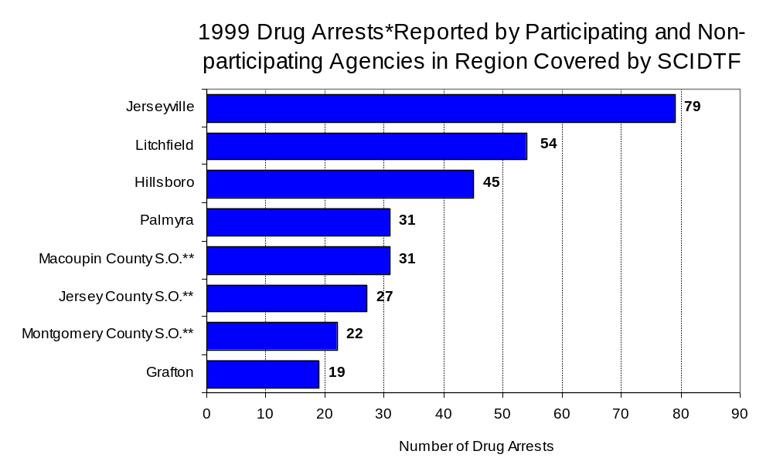
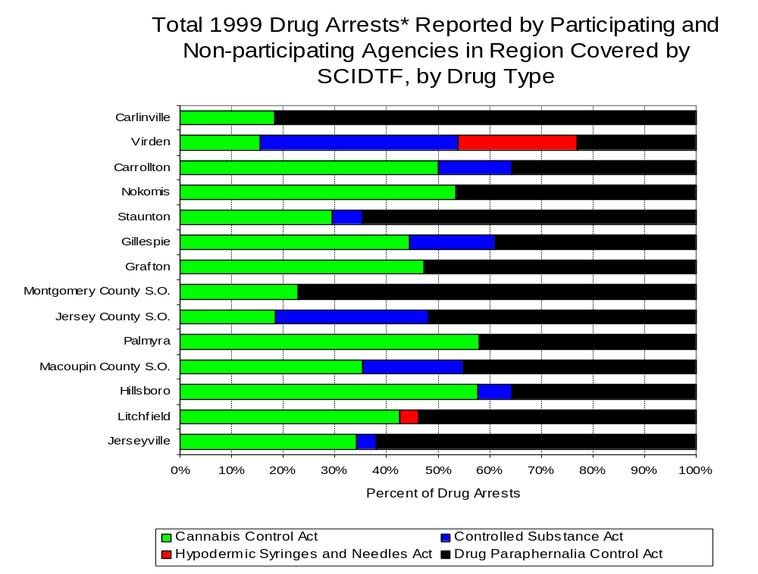
In addition to the dramatic difference in the number of drug arrests made, there are also differences in the types of drug law violation arrests across the agencies in the region. In 1999, violations of the Cannabis Control Act and the Drug Paraphernalia Control Act accounted for the majority of arrests across most individual agencies in the region covered by SCIDTF (Figure 7).
Source: Illinois State Police *Agencies reporting 20 or more drug arrests
**Agencies participating in SCIDTF
Figure 6
Source: Illinois State Police *Agencies reporting ten or more drug arrests
Figure 7

Between 1993 and 1999, the number of combined cannabis and controlled substances arrests made by SCIDTF more than doubled, from 41 to 83 (Figure 8). Unlike drug arrests made by most local police departments in the region, violations of the Controlled Substances Act accounted for the majority of drug arrests made by SCIDTF between 1997 and 1999. Between 1993 and 1999, the number of SCIDTF arrests for violations of the Cannabis Control Act increased 30 percent, from 27 to 35, while arrests for violations of the Controlled Substances Act more than tripled, from 14 to 48 (Figure 8).

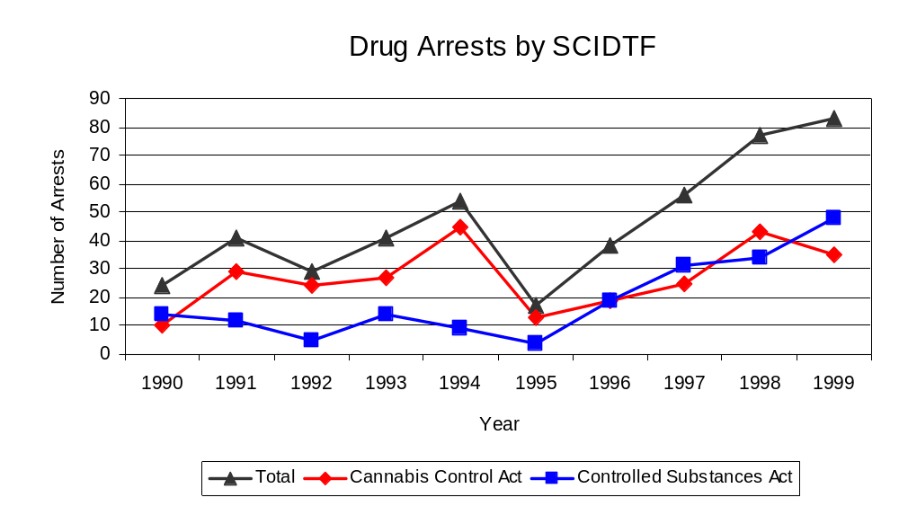
Between 1993 and 1999, the proportion of drug arrests accounted for violations of the Controlled Substances Act increased 58 percent for participating agencies. Similarly, for SCIDTF, the proportion of drug arrests accounted for by violations of the Controlled Substances Act increased 70 percent between 1993 and 1999. Conversely, the proportion of drug arrests accounted for by violations of the Controlled Substances Act decreased 37 percent for non-participating agencies. In 1999, 58 percent of the drug arrests made by SCIDTF were for violations of the Controlled Substances Act, compared to 34 percent in 1993. In 1999, arrests for controlled substances violations accounted for 35 percent of the drug arrests made in the participating agencies and 11 percent for the non-participating agencies, compared to 22 percent and 18 percent, respectively, in 1993. Arrests by SCIDTF were more likely than arrests by either participating or non-participating agencies to involve violations of Illinois’ Controlled Substances Act, as opposed to the Cannabis Control Act. One interpretation of this pattern is that SCIDTF is more focused in who they are targeting and arresting than local departments, and are also getting a more serious drug law violator, since violations of the Controlled Substances Act are more likely to involve felony-level offenses.
Source: SCIDTF
Figure 8

The data presented below represent the percent of total drug arrests made by participating agencies accounted for by SCIDTF, when compared to participating agencies. An upper and lower bound is shown in Figure 9 which accounts for whether or not the units numbers are counted as part of the UCR submissions made by local departments (which is unknown at this point). The upper bound indicates the percentage of arrests if all of the SCIDTF arrests are included in the local UCR submissions. The lower bound indicates the percentage if none of the SCIDTF arrests are included in the local UCR submissions. It is estimated that the proportion of all drug arrests by participating agencies accounted for by SCIDTF was between 38 and 60 percent in 1993, then increased to between 64 and 100 percent in 1999. Thus, despite the fact that the officers assigned to SCIDTF accounted for a small proportion of total officers in the region, they accounted for a relatively large proportion of the drug arrests in the region.
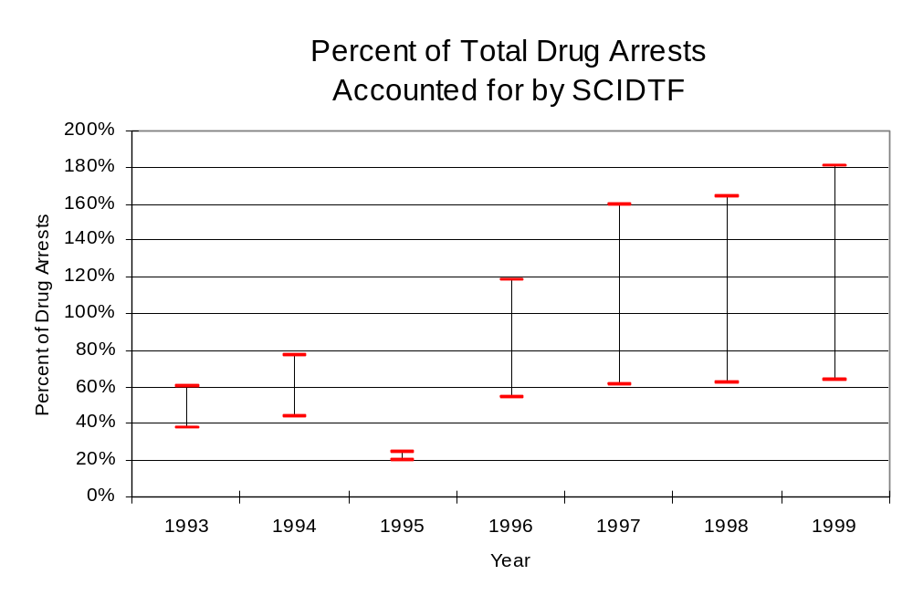
Source: ICJIA calculations using Illinois State Police and SCIDTF data
Figure 9

The number of arrests for violations of Illinois’ Cannabis Control Act in Jersey, Macoupin, Montgomery and Greene counties totaled 175 in 1999, which was a 16 percent increase from the 151 arrests made for cannabis violations in 1993. Between 1993 and 1999, the proportion of all drug arrests accounted for by violations of the Cannabis Control Act in the four-county region increased 4 percent, from 81 percent in 1993 to 84 percent in 1999). Agencies not participating in SCIDTF accounted for the largest portion (86 percent) of the total number of arrests for cannabis violations. SCIDTF reported a total of 35 arrests for cannabis violations in 1999, 8 percent of the unit's drug arrests.

During the period analyzed, the cannabis arrest rate for the region covered by SCIDTF increased 14 percent, from 131 arrests per 100,000 population in 1993 to 149 arrests per 100,000 population in 1999. However, the cannabis arrest rate in the participating agencies decreased 46 percent, from 105 to 57 arrests per 100,000 population, while the arrest rate in the non-participating agencies increased 48 percent from 151 to 223 arrests per 100,000 population. The cannabis arrest rate for SCIDTF also increased 24 percent, from 54 to 66 arrests per 100,000 population (Figure 10). Thus, the arrest rate for violations of the Cannabis Control Act was collectively higher in the area served by non-participating agencies than in the area served by participating agencies.

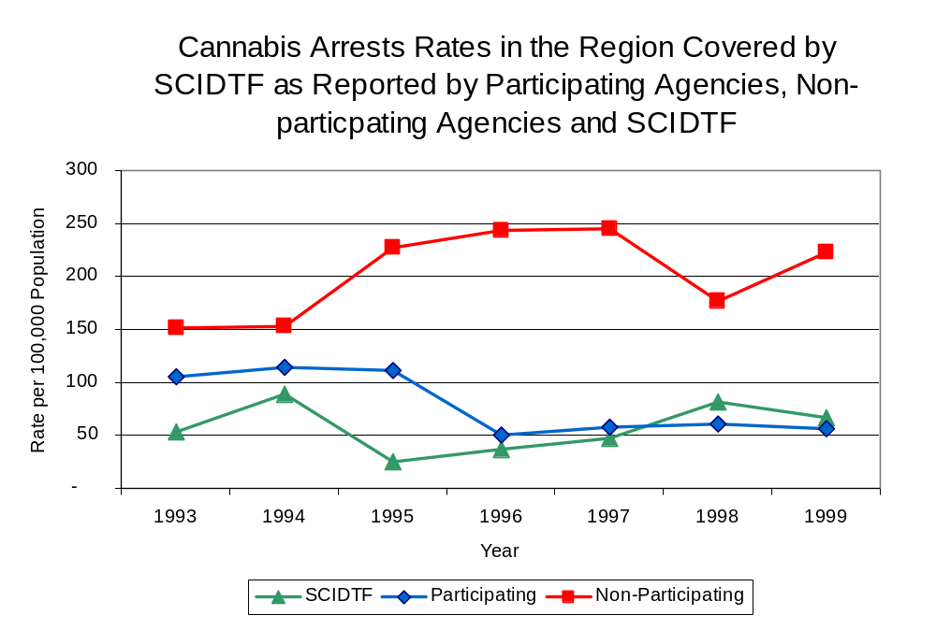
Source: ICJIA calculations using
Illinois State Police and SCIDTF data
Figure 10
The data presented in Figure 11 represent the percent of cannabis arrests by participating agencies accounted for by SCIDTF. An upper and lower bound is shown which accounts for whether or not the unit’s numbers are counted as part of the UCR submissions made by local departments (which is unknown at this point). The upper bound indicates the percentage of arrests if all of the SCIDTF arrests are included in the local UCR submissions. The lower bound indicates the percentage if none of the SCIDTF arrests are included in the local UCR submissions. It is estimated that the proportion of cannabis arrests by participating agencies accounted for by SCIDTF was between 34 and 51 percent in 1993, but increased to between 54 and 100 percent in 1999.

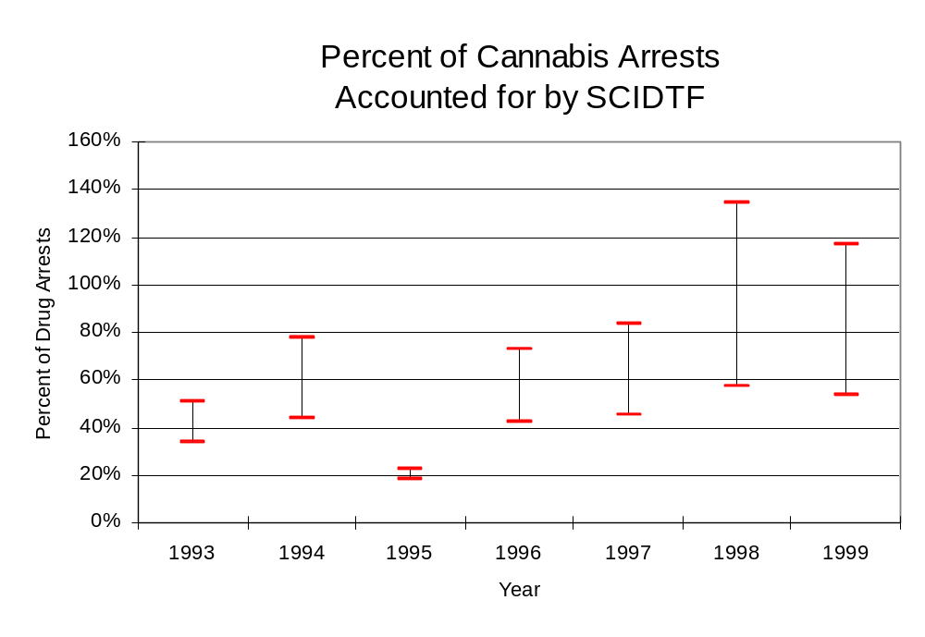
Source: ICJIA calculations using Illinois State Police
and SCIDTF data
Figure 11
In Jersey, Macoupin, Montgomery and Greene counties the number of arrests for violations of Illinois’ Controlled Substances Act decreased 6 percent between 1993 and 1999, from 36 to 34. Between 1993 and 1999, the proportion of all drug arrests accounted for by violations of the Controlled Substances Act in the four-county region decreased from 19 percent to 16 percent. In 1999, SCIDTF reported 48 arrests for controlled substance violations, 22 percent of all drug arrests reported to the Authority by the unit.

Between 1993 and 1999, the arrest rate for controlled substances act violations for the region covered by SCIDTF decreased 7 percent, from 31 to 29 arrests per 100,000 population (Figure 12). The controlled substances arrest rate in the participating agencies remained relatively stable at 30 arrests per 100,000 population, while the arrest rate in the non-participating agencies decreased 14 percent, from 32 to 28 arrests per 100,000 population. The controlled substances arrest rate for SCIDTF more than doubled, from 28 to 91 arrests per 100,000 population (Figure 12). Thus, the arrest rate for violations of Controlled Substance Act was generally higher in the non-participating agencies than the participating agencies.

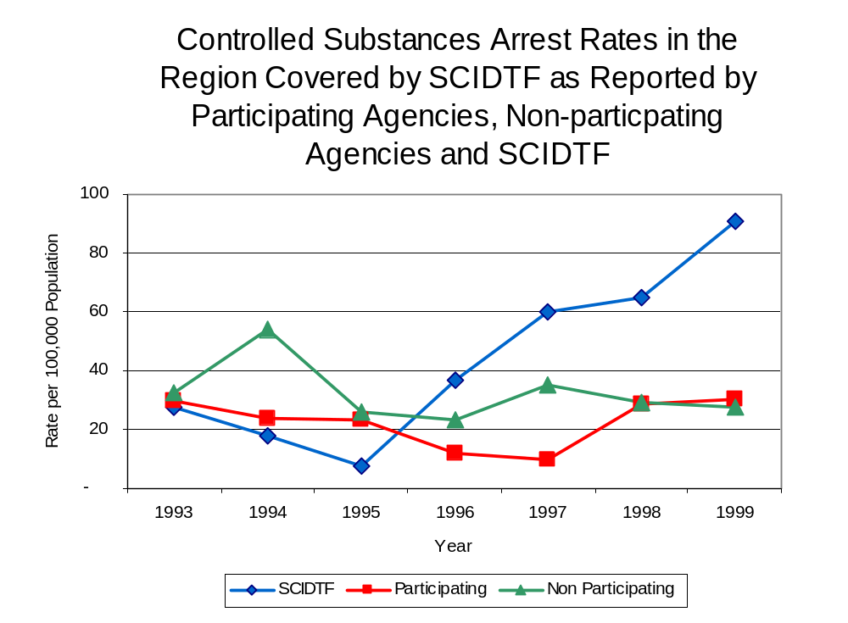
Source: ICJIA calculations using Illinois State Police and SCIDTF data
Figure 12
The data presented in Figure 13 represent the percent of controlled substances arrests by participating agencies accounted for by SCIDTF. An upper and lower bound is shown which accounts for whether or not the units numbers are counted as part of the UCR submissions made by local departments (which is unknown at this point). The upper bound indicates the percentage of arrests if all of the SCIDTF arrests are included in the local UCR submissions. The lower bound indicates the percentage if none of the SCIDTF arrests are included in the local UCR submissions. It is estimated that the proportion of controlled substances arrests by participating agencies accounted for by SCIDTF was between 48 and 93 percent in 1993, but increased to between 75 and 300 percent in 1999.

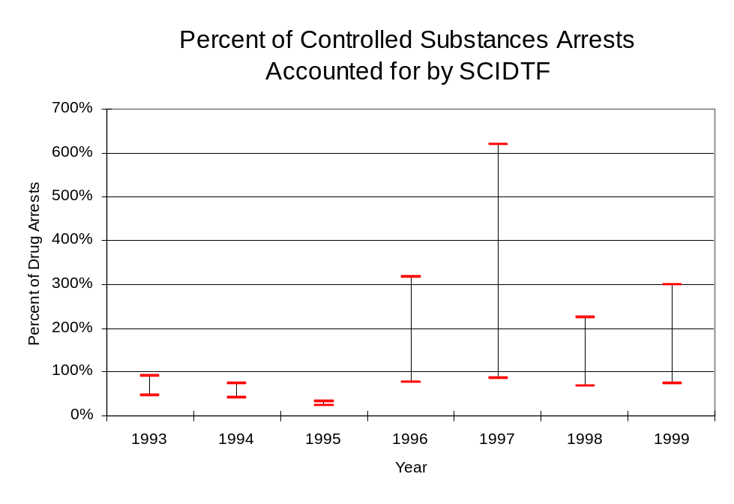
The majority of all drug arrests reported by SCIDTF are for delivery. Between 1993 and 1999, the number of drug delivery arrests made by SCIDTF more than doubled, from 39 to 81. Arrests for drug delivery accounted for 81 percent of all drug arrests made by SCIDTF between 1993 and 1999. When cannabis and controlled substance arrests were examined separately, during the period analyzed, arrests for delivery of controlled substances accounted for 85 percent of the total number of arrests made for violations of the Controlled Substance Act, whereas, arrests for the delivery of cannabis accounted for 79 percent of all arrests for violations of the Cannabis Act. Thus, the proportion of delivery arrests was consistent with the number of arrests made between 1993 and 1999.
Source: ICJIA calculations using Illinois State Police and SCIDTF data
Figure 13
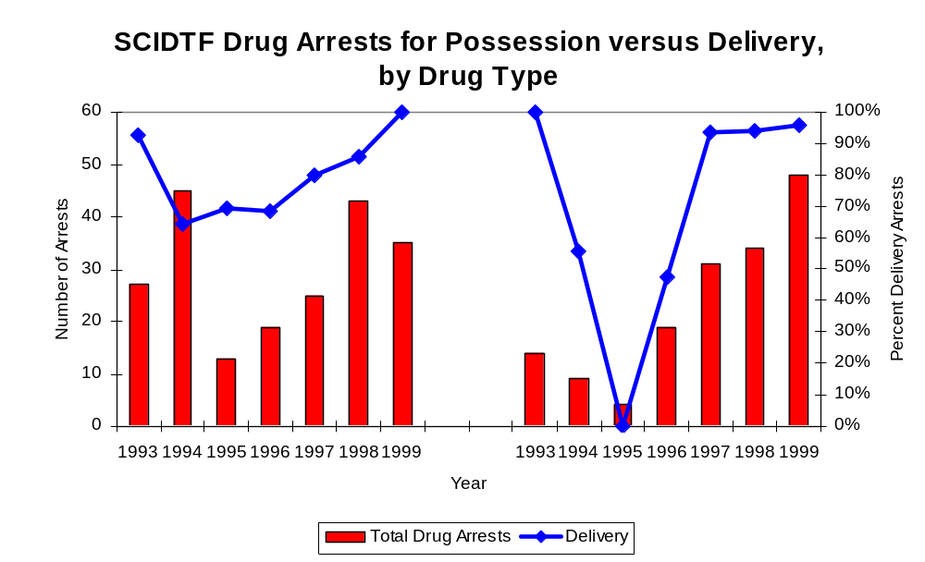
Figure 14
Source: ICJIA calculations using SCIDTF data
Cannabis Control Act

Controlled Substances Act

IV. Trends in Drug Seizures

Drugs seized by law enforcement agencies are another indicator of the extent and nature of illegal drug trade in a jurisdiction. When illegal drugs are seized by law enforcement agencies, all or a portion of the total amount seized is submitted to a crime lab for analysis. Most agencies submit drugs to one of the Illinois State Police crime labs. These labs record the quantity of drugs submitted from each county. This section discusses trends in the quantities of illegal drugs seized and submitted to the Illinois State Police from local law enforcement agencies in Jersey, Macoupin, Montgomery and Greene counties as well as the quantities of drugs seized by SCIDTF. It is important to note, however, that while SCIDTF data report the total quantities of drugs actually seized, local agency data only represent the quantities of seized drugs that are submitted to the Illinois State Police for analysis. County-level cannabis, cocaine and methamphetamine seizure rates for Illinois' 102 counties are provided in maps located in the Appendix of this report .

As in most Illinois jurisdictions, cannabis accounts for the majority of illegal drugs seized in the four-county region covered by SCIDTF. The quantity of cannabis seized and submitted by law enforcement agencies in Jersey, Macoupin, Montgomery and Greene counties decreased 86 percent, from 41,945 grams in 1993 to 5,800 grams in 1999. Also, the quantity of cannabis seized by SCIDTF dramatically decreased between 1993 and 1999, from 2,413,822 grams to 6,009 grams, with 3,251,063 grams being seized in 1994, the largest amount in the period analyzed (Figure 15). In 1999, SCIDTF's cannabis seizure rate of 11,384 grams per 100,000 population was lower than the statewide cannabis seizure rate of 31,533 grams per 100,000 population, but greater than the seizure rate of 4,928 grams per 100,000 population in the four-county region covered by SCIDTF (Map 2). (Note: In order to display the seizure data for every year on the graph below, it was necessary to set the Y-axis scale to 500,000).

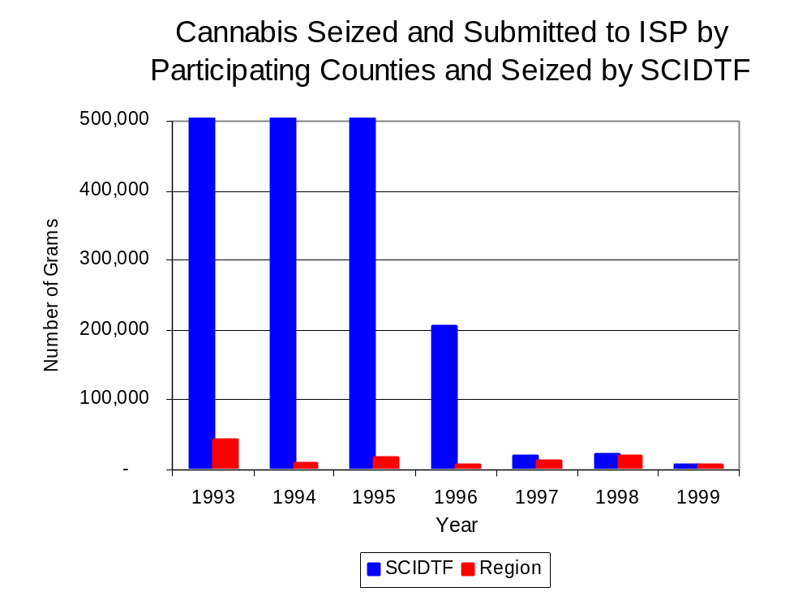
Figure 15
Source: Illinois State Police and SCIDTF
Between 1993 and 1999, a combination of crack and powder cocaine has accounted for a small proportion of drugs seized in the four-county region covered by SCIDTF. However, the quantity of cocaine seized and submitted by law enforcement agencies in Jersey, Macoupin, Montgomery and Greene counties increased 32 percent, from 505 grams in 1993 to 667 grams in 1999. Between 1993 and 1999, the quantity of cocaine seized by SCIDTF decreased 2 percent, from 828 grams to 811 grams.

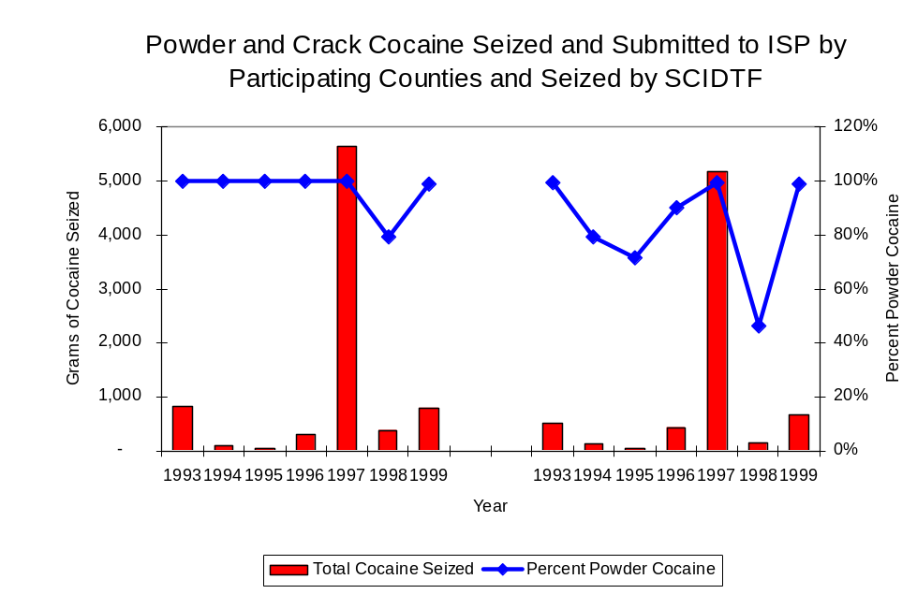
As a result, the proportion of all cocaine seized by SCIDTF accounted for by powder cocaine remained relatively stable between 1993 and 1999; whereas local seizures revealed a bit more variation. For SCIDTF, powder cocaine accounted for nearly all cocaine seized in every year examined. Similarly, with the exception of 1998, powder cocaine accounted for the majority of local seizures of cocaine, accounting for 84 percent of all cocaine seized in the four-county region (Figure 16). In 1999, SCIDTF's cocaine seizure rate of 1,536 grams per 100,000 population was significantly greater than the cocaine seizure rate of 567 grams per 100,000 population in the four-county region covered by SCIDTF, but significantly less than the statewide cocaine seizure rate of 15,735 grams per 100,000 population (Map 3).
Figure 16
Source: Illinois State Police and SCIDTF
SCIDTF
Region

The total quantity of illegal drugs seized and submitted by law enforcement agencies in Jersey, Macoupin, Montgomery and Greene counties increased between 1989 and 1999, from 6,438 grams to 6,599 grams, with a high of 42,545 grams seized in 1993. On the other hand, the total quantity of illegal drugs seized by SCIDTF decreased from 2,414,717 grams in 1993 to 7,304 grams in 1999.

During the period, methamphetamine seizures accounted for a relatively small proportion of total drugs seized by SCIDTF and the four-county region covered by SCIDTF. Between 1994 and 1999, the quantity of methamphetamine seized by law enforcement agencies in Jersey, Macoupin, Montgomery and Greene counties increased from nearly nine grams to 26 grams, while seizing a period high quantity of 743 grams in 1996. SCIDTF, on the other hand, did not seize any methamphetamine between 1994 and 1998, while reporting 23 grams of methamphetamine seized in 1999. In 1999, SCIDTF had a methamphetamine seizure rate of 43 grams per 100,000 population, nearly double the rate in the four-county region covered by SCIDTF, but less than one-half the statewide seizure rate of 98 grams per 100,000 population, respectively (Map 4).

Trends in Prosecutions for Drug Offenses and All Felonies

Although Illinois has one of the best court reporting systems in the country, the Administrative Office of the Illinois Court only collects information regarding the aggregate number of court filings. Currently, there are no statewide data available on court filings by offense type. The Administrative Office of the Illinois Courts reports data on felony criminal court cases. After screening a case and deciding it warrants further action, the state’s attorney must file formal charges in court. Felony cases can be punished by a probation term up to four years and incarceration for more than one year.

Between 1989 and 1999, the number of felony filings in the four-county region covered by SCIDTF increased 46 percent, from 521 to 761 (Figure 17).
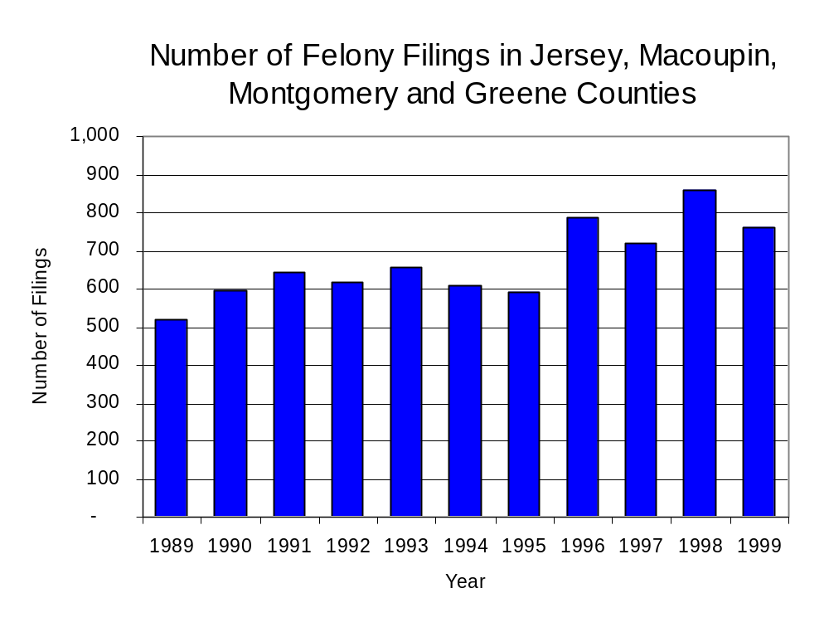
Figure 17
Source: Administrative Office of the Illinois Courts

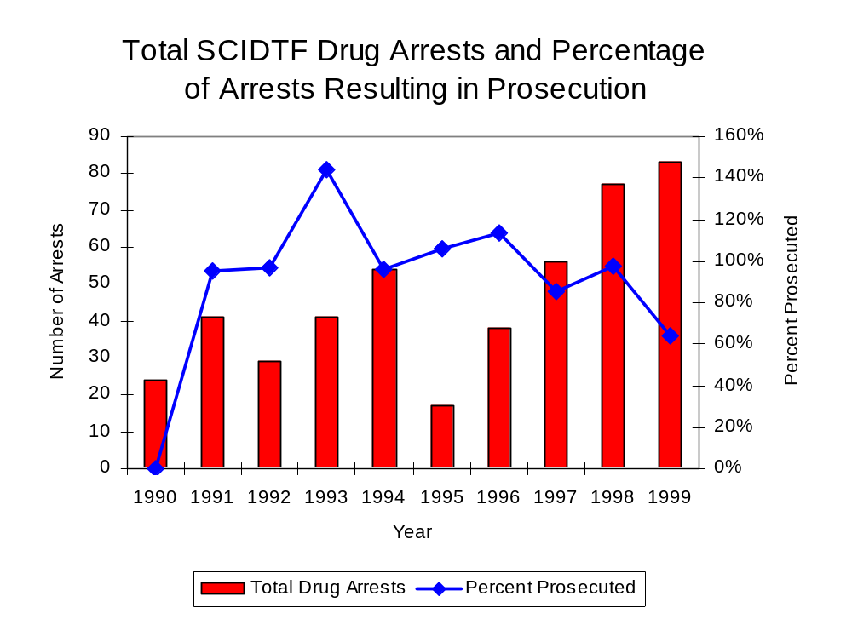
Between 1990 and 1999, there were a total of 514 drug prosecutions initiated as a result of SCIDTF arrests in Jersey, Macoupin, Montgomery and Greene counties. During this time, the number of SCIDTF drug arrests more than tripled, from 24 arrests in 1990 to 83 arrests in 1999 (Figure 18). Between 1990 and 1999, 90 percent of drug arrests by SCIDTF resulted in prosecution. No prosecution data was reported for 1990. Thirty-nine percent of SCIDTF drug offender prosecutions during this period were for violations of the Controlled Substance Act. In some years, the proportion of arrests resulting in a prosecution exceeded 100 percent. This may be due to some slight differences in the timing of an arrest and the filing of charges. It could also be due to charges, rather than defendants, being reported by the unit. Also, some offenders have charges filed, and a subsequent warrant issues, without an arrest taking place.
Figure 18
Source: SCIDTF

Between 1990 and 1999, 93 percent (384) of the 415 drug offenders who were prosecuted as a result of SCIDTF activity were convicted. Convictions for controlled substances accounted for 37 percent of all SCIDTF initiated convictions during the period analyzed.

VI. Trends in Percent of Convicted Drug Offenders Sentenced to Prison

Anyone convicted of a felony in Illinois can be sentenced either to prison or probation, or receive conditional discharge. A number of factors influence the type and length of sentence imposed on convicted felons, including the severity of the crime, the offender’s criminal and social history, safety of the community and legislation affecting certain types of offenses. For some types of convictions, a sentence to prison is required by state statute.

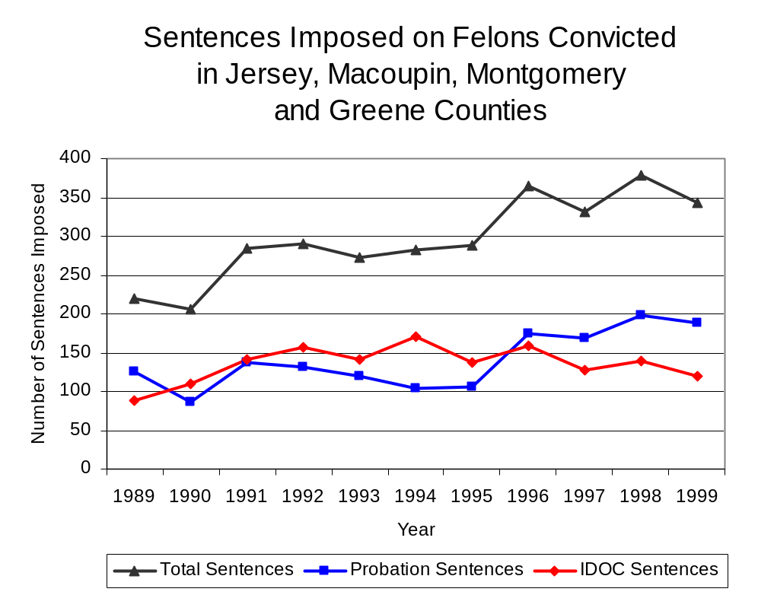
Between 1989 and 1999, the number of offenders convicted of a felony and sentenced in the four-county region covered by SCIDTF increased 56 percent, from 220 to 344. Although the number of convicted felons sentenced to the Illinois Department of Corrections (IDOC) increased 36 percent between 1989 and 1999, from 88 to 120, the proportion of felons sentenced to IDOC decreased during the same period, from 40 percent to 35 percent of total felony sentences. In 1999, 188 probation sentences were imposed on convicted felons, 49 percent more than the 126 probation sentences in 1989 (Figure 19). However, the proportion of felons sentenced to probation decreased from 57 percent in 1989 to 55 percent in 1999. Sentences other than prison or probation account for the remaining 10 percent of felony sentences imposed in 1999.
Figure 19
Source: Administrative Office of the Illinois Courts

Between 1990 and 1999, the number of SCIDTF drug offenders convicted and sentenced increased from zero to 46. During the period analyzed, the number of convicted SCIDTF drug offenders sentenced to probation increased from zero in 1990 to 17 in 1999, although in 1995, the number of convicted SCIDTF drug offenders sentenced to probation reached a high of 33. Similarly, the number of convicted SCIDTF drug offenders sentenced to jail increased from zero to 15 and the number of drug offenders sentenced to prison increased from zero to 14 (Figure 20). In 1999, among those SCIDTF drug offenders convicted and sentenced, probation sentences accounted for the largest proportion (37 percent), followed by jail sentences (33 percent) and prison sentences (30 percent).
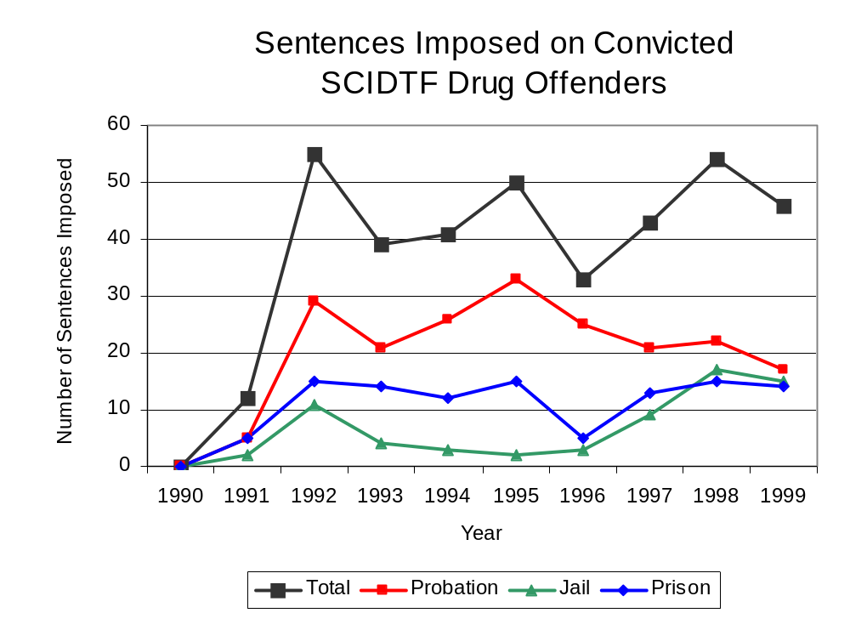
Figure 20
Source: SCIDTF

Between state fiscal years 1990 and 1999, the number of new court commitments to IDOC’s Adult Division for drug offenses from the four-county region covered by SCIDTF more than doubled, from nine to 22. The number of drug offender admissions by SCIDTF also increased during the period, from zero to 19 (Figure 21). During the period analyzed, prison sentences resulting from SCIDTF cases accounted for more than one-half (54 percent) of all drug-law violators sentenced to prison from the region where SCIDTF operates.
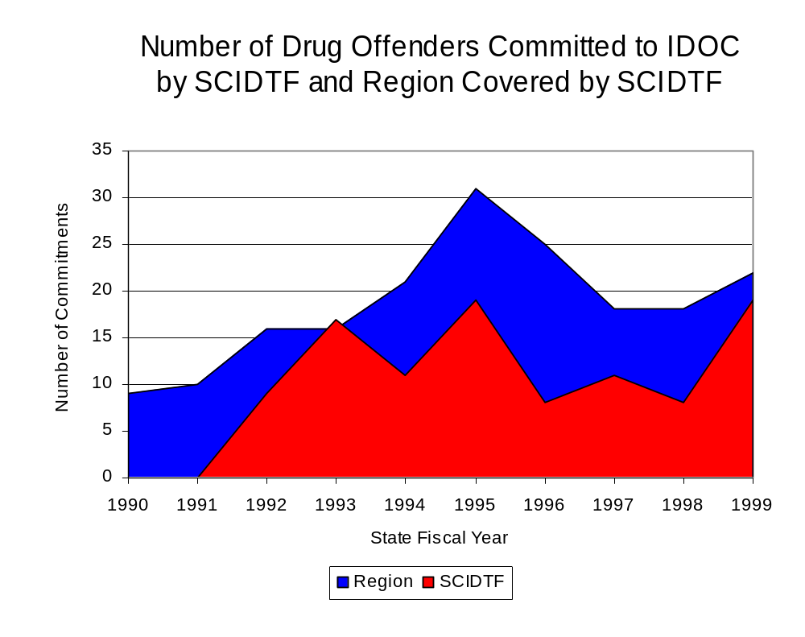
Figure 21
Source: Illinois Department of Corrections and SCIDTF

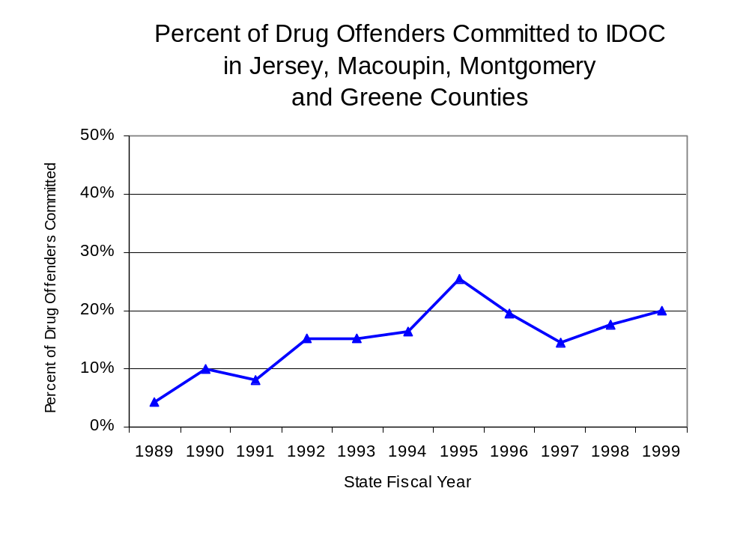
During the period analyzed, drug offenders accounted for an increasing proportion of adults convicted and sentenced to prison from Jersey, Macoupin, Montgomery and Greene counties. In 1989, drug offenses accounted for 4 percent of all commitments to IDOC, compared to 20 percent in 1999 (Figure 22).
Figure 22
Source: Illinois Department of Corrections

Penalties for drug offenses were also examined between 1993 and 1999. Class 4 felonies accounted for the largest proportion (54 percent) of sentences to IDOC for drug offenses, followed by Class 3 felonies (19 percent), Class 1 and Class X felonies (10 percent each) and Class 2 felonies (6 percent). Between 1993 and 1999, the number of Class 4 felony sentences decreased from ten to eight, while Class 1 and Class 3 felony sentences both increased, from two to six. Class X felony sentences also increased from zero to two, while the number of Class 2 felonies decreased during the period analyzed, from two to zero (Figure 23).

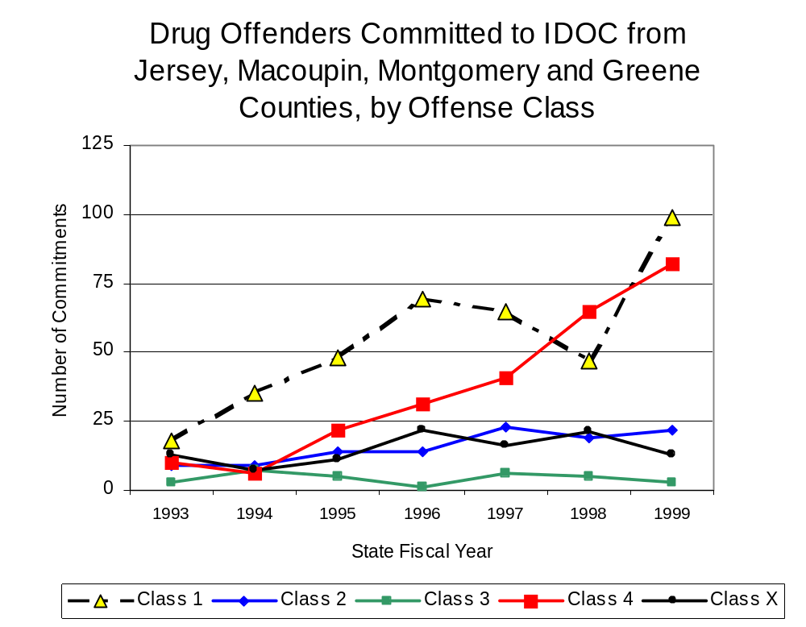
Figure 23
Source: Illinois Department of Corrections

Because of the increase in Class 4 felony sentences to IDOC between 1993 and 1999, the mean sentence length for Class 4 felonies also increased slightly from 1.8 to 2.4 years, during the period. However, the mean sentence length for Class 2 felonies decreased from six to zero, and the mean sentence for a Class 3 felony slightly decreased from three to 2.8 years. The Class 1 sentence lengths increased 15 percent, from four to 4.6 years, while the mean sentence length for Class X felonies greatly increased, during the period analyzed, from zero to 6.5 years.

Based on data collected from the 2000 Illinois Adult Probation Outcome Study, fewer than 10 percent of all adults discharged from probation in Greene, Jersey, Macoupin and Montgomery counties combined during the study period (November 2000) were convicted of drug-law violations.

VII. Trends in Drug Treatment Admissions in SCIDTF Region by Drug Type

In addition to considering indicators of the extent and nature of drug abuse as reported through the criminal justice system (for example, arrests and prison sentences), there are indicators of substance abuse available from other Illinois social service agencies. Overseeing and supporting treatment for substance users, whether they are referred from the criminal justice system or elsewhere, is the responsibility of the Illinois Department of Human Services’ Office of Alcoholism and Substance Abuse (OASA). It is important to note, however, that while OASA data represent the majority of the overall demand for substance abuse treatment in the state, some private programs provide treatment services to a smaller but significant number of clients who may not be included in the state’s reporting system.

In state fiscal year 1999, OASA reported 544 admissions for alcohol or drug abuse treatment from Jersey, Macoupin, Montgomery and Greene counties, 58 percent less than the 1,287 admissions in 1989 (Figure 24). Among the 544 admissions to substance abuse treatment in state fiscal year 1999, 69 percent (375) reported alcohol as their primary substance of abuse, while abuse of illicit substances accounted for 30 percent, while 1 percent reported no primary substance of abuse.

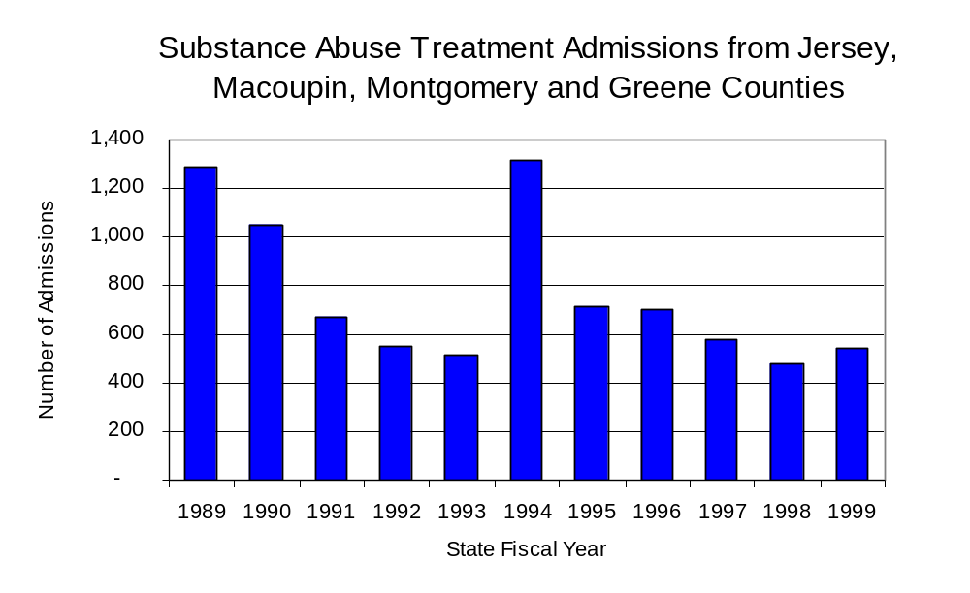
Figure 24
Source: Illinois Department of Human Services’
Office of Alcoholism and Substance Abuse
While drug treatment admissions can be considered a measure of the demand placed on a specific component of the human services system within Illinois, the extent and nature of drug treatment admissions could also be indicative of the substance abuse problem within a particular region. In some respects, the characteristics of those admitted to drug treatment can be considered a profile of the most serious drug abusers in the community, since admission to treatment requires a documented, formal assessment of a drug problem and a level of substance abuse warranting treatment. By comparing the types of drugs of abuse reported by those admitted to substance abuse treatment with the types of drugs of drugs involved in law enforcement agency arrests, one can get a sense of the degree to which arrests reflect the drugs which are most problematic within a community.

In the following analyses, the percent of arrests accounted for by drugs classified under Illinois’ Controlled Substances Act (primarily cocaine, heroin, and methamphetamine) versus the Cannabis Control Act (marijuana) across the participating agencies combined, non-participating agencies combined, and SCIDTF are compared to the proportion of drug treatment admissions accounted for by these groups of substances. From these comparisons, a number of general conclusions can be made. First, the proportion of arrests made by local police departments (including those participating in SCIDTF and non-participating agencies) accounted for by marijuana (Cannabis Control Act) was fairly close to the proportion of drug treatment admissions from the covered region accounted for by marijuana. Thus, there is somewhat of a convergence between the drugs involved in local agency arrests and treatment admissions. The majority of arrests by SIDTF, however, were for drugs other than marijuana (Controlled Substances Act). Thus, while SCIDTF arrests may reflect the most widely available and used drug in the region, they also tend to involve the substances individuals are seeking and receiving treatment for (Figure 25).

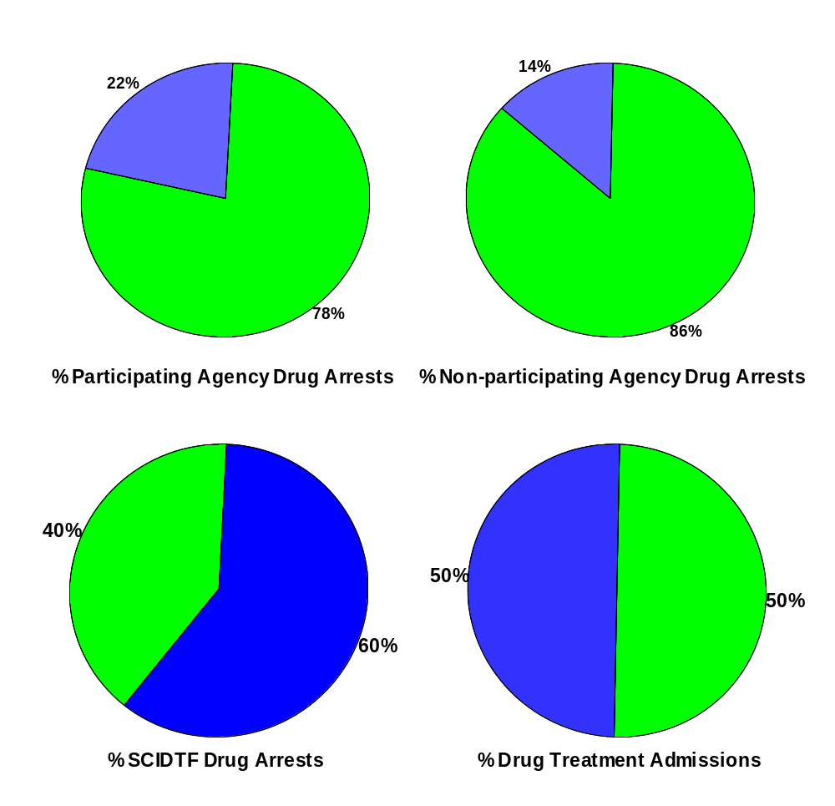
CannabisControlled Substances
Comparison of Drug Arrests by SCIDTF and Participating and Non-participating Agencies vs. Drug Abuse Treatment Admissions in Jersey, Macoupin, Montgomery and Greene Counties, 1999
Source: Illinois Department of Human Service's Office of Alcoholism and Substance Abuse and SCIDTF
Figure 25

VIII. Trends in Drug Exposed Births

Illinois continues to experience the effects of prenatal substance abuse. In Illinois, if a baby is born and thought to have been exposed to illegal substances or alcohol, either through observation by physicians or toxicology tests, the case is reported to the Illinois Department of Children and Family Services. These cases are then investigated by DCFS to verify the child’s prenatal exposure to either alcohol or illegal substances. Between state fiscal years 1989 and 1999, nearly one-half (50) of Illinois’ 102 counties reported at least one case of a substance-affected infant.

Between state fiscal years 1989 and 1999, the number of drug-exposed infant cases reported in the four-county region covered by SCIDTF remained at one reported case; however, in 1996, there were 6 cases reported. Between state fiscal years 1989 and 1999, eight cases or 53 percent of all cases reported were verified as involving prenatal drug use by a DCFS investigation. Mirroring the trend of reported cases, verified cases of drug-exposed infants in the SCIDTF region also remained at one case in both 1989 and 1999 (Figure 26).
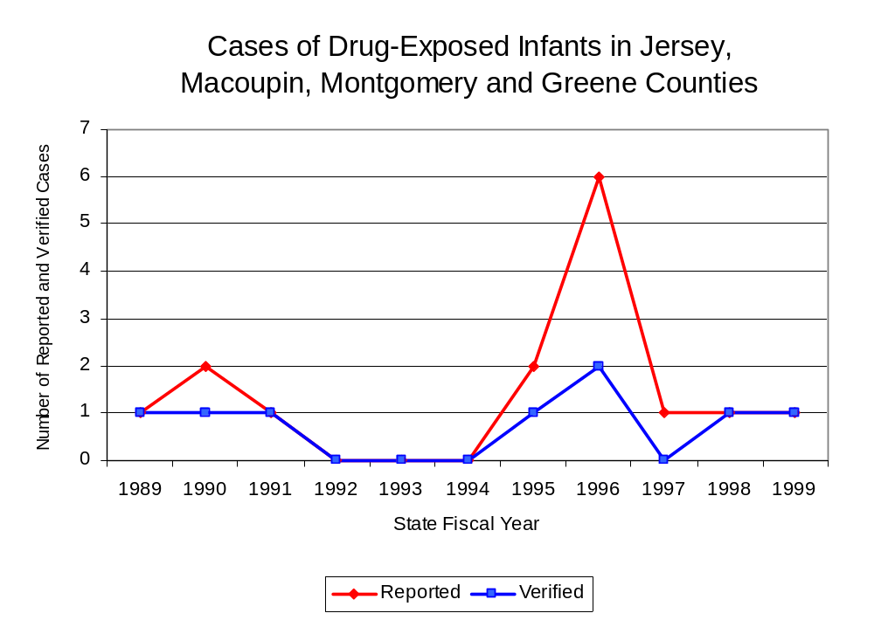
Source: Department of Children and Family Services
Figure 26

IX. Summary of Drug Situation

Although the distribution of illegal drugs is difficult to measure precisely, data obtained from criminal justice sources can be helpful in estimating drug availability. Information from a recent survey of Illinois drug enforcement units, as well as the most up-to-date data available on drug price, are presented as indicators of the drug supply in Illinois.

In 1995, 1996 and 1998, the Authority conducted a survey of each MEG and task force in Illinois to gauge the perceived availability of drugs in the areas they cover. Questions were asked concerning the availability of specific drugs, and results were analyzed by region of the state. MEGs and task forces are classified as being either urban, rural or mixed urban/rural based upon the classification of the county(s) that each unit covers, and, for purposes of this report, are compared to the average of similar units.

According to SCIDTF survey responses, cannabis, cocaine and crack continued to be the most visible drugs on the street and were all reported to be “readily available” across all regions analyzed. While perceived availability of cannabis remained relatively unchanged in the four-county region covered by SCIDTF, the perceived availability of cocaine increased slightly since the 1996 survey, while Methamphetamine decreased in the region covered by SCIDTF. All other drug types decreased in the region covered by SCIDTF from the 1996 survey. Methamphetamine was reported as moderately available across Illinois but available to a somewhat lesser degree in the region covered by SCIDTF. The perceived availability of all drugs, excluding cannabis and Methamphetamines, tended to be greater across Illinois and in other mostly rural regions than in the region covered by SCIDTF (Figure 27).
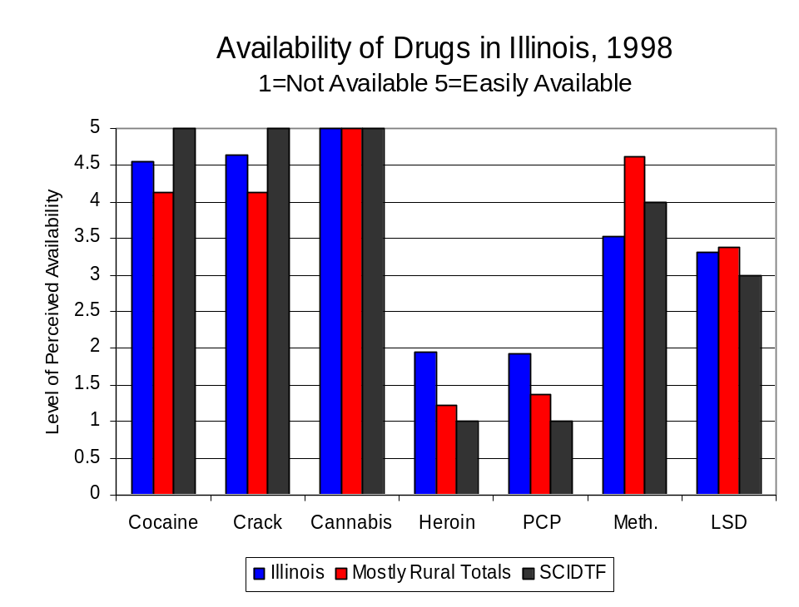
Figure 27
Source: Authority Survey of Illinois MEGs and task forces
Another market indicator that can be used to assess availability is drug price. Lower prices tend to suggest a sufficient supply to meet demand, while increasing prices indicate decreased availability.

Based on a statewide survey of MEG and task force units, the average price of cocaine, crack and methamphetamine appear to be relatively stable across all regions surveyed in 1998, while prices heroin and cannabis appear to vary somewhat across Illinois. The average price of cannabis in the region covered by SCIDTF increased between 1996 and 1998, and remained unchanged in the other mostly rural regions. The 1998 average price of cocaine reported by SCIDTF was $100 per gram, compared to $98 per gram across Illinois and $98 per gram reported by all MEGs and task forces in other mostly rural regions (Figure 28). Also, the average price of methamphetamine in the region covered by SCIDTF was reported as $100 per gram, higher than the price of $96 per gram across Illinois and the price of $94 per gram reported by all other MEGs and task forces in mostly rural regions. In 1998, the average price of cannabis was reported as approximately $15 per gram in the SCIDTF region, $8 per gram in mostly rural regions and $8 per gram across Illinois.

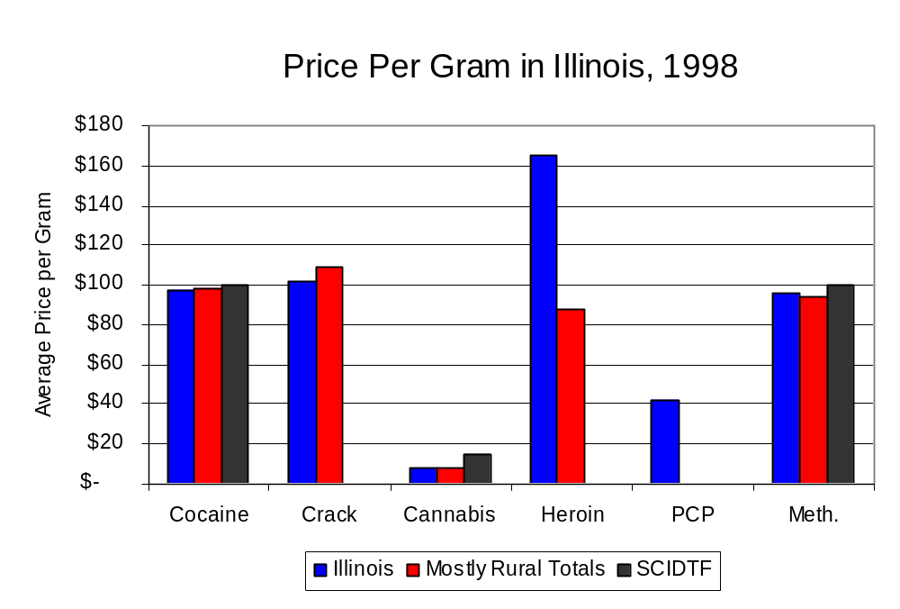
Figure 28
Source: Authority Survey of Illinois MEGs and task forces

X. Appendices
1999 Percent of Illinois'
County-level Population Covered by an Authority-funded Multi-jurisdictional Enforcement Group or Task Force
Map 1
* Shaded counties indicate that at least one law enforcement agency within the county participates in a MEG or task force
Percent of County Population Covered by MEG or Task Force

1999 Illinois
Cannabis
Seizure Rates, by County
Map 2
Cannabis Seizure Rate
(rate per 100,000 population)
1999 Illinois
Cocaine
Seizure Rates, by County
Map 3
Cocaine Seizure Rate
(rate per 100,000 population)
1999 Illinois Methamphetamine
Seizure Rates, by County
Map 4
Methamphetamine Seizure Rate
(rate per 100,000 population)

Bibliography

Administrative Office of the Illinois Courts, Annual Report to the Supreme Court of Illinois.
1989 through 1999 reports, Springfield, Illinois.

Administrative Office of the Illinois Courts’ Probation Division, Statewide Probation Data
Report. 1989 through 1999 reports, Springfield, Illinois.

Illinois Department of Human Services’ Office of Alcoholism and Substance Abuse. Data
provided for state fiscal years 1989 through 1999, Springfield, Illinois.

Illinois Department of Children and Family Services, Child Abuse/Neglect Statistics Report,
1989 through 1999 reports, Springfield, Illinois.

Illinois Department of Corrections. Data provided for fiscal years 1989 through 1999,
Springfield, Illinois.

Illinois State Police, Crime in Illinois. 1993 through 1999 reports, Springfield, Illinois.

Illinois State Police, Drug Statistics Report. Monthly reports, January 1989 through
December 1999, Springfield, Illinois.

South Central Illinois Drug Task Force. Monthly reports, January 1989 through December
1999, Litchfield, Illinois.

U.S. Bureau of the Census.


George H. Ryan, Governor
Peter B. Bensinger, Chairman
Candice M. Kane, Executive Director

